

**GEOG 2016**

**Introduction to Urban Geography**

**Assignment 3: Consultancy Project**

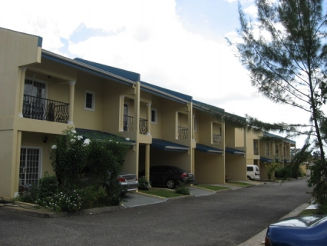

**Kasajia Edwards 816002291**

**Shaanta Jaglal 816002222**

**Nasyah John 816001140**

**Kieran Doolarchan 816001265**

**Arron Williams 816000576**

**DISCLAIMER**

This material is based upon work supported by The Department of Geography, UWI St Augustine. Any opinions, findings, conclusions, or recommendations are those of the author and do not reflect the views of UWI or the Department of Geography, its employees or its administration.

# **Conversion of the St. Augustine Nurseries to HDC housing**

**A Project Evaluation Case**

**Kasajia Edwards, Kieran Doolarchan, Arron Williams,**

**Shaanta Jaglal and Nasyah John**

**Faculty of Food and Agriculture**

**Department of Agriculture**

**UWI, St. Augustine**

**TABLE OF CONTENTS**

Introduction 5 - 6

Literature Review 7 - 10

Methodology 11

Maps 12 - 14

Discussion 15 - 20

Conclusion 21

References 22 - 23

**INTRODUCTION**

According to Susan S. Fainstein (2015), urban development can be defined as the design and regulation of different land uses taking into consideration physical structures built, their functions and impacts to society. Several disciplines are involved in this process such as engineering and architecture. When practicing urban planning, it typically uses green space and a full evaluation of any proposed project for the conversion of the area in question into an urban site such as housing developments, industry or shops. In some cases where the skilled labour and technical resources are available, GIS is used in the assessment or an urban expansion project. This is used to show changes in land use over time, give site assessments and to visualize future impacts of changes to the area and to surrounding areas. The process of urban development is a common solution when dealing with population growth and increasing density in an area.  
 The area coming into question is the St. Augustine Nurseries. The nursery is in a prime location around the East - West corridor. The East- West Corridor can be regarded as one of the most developed or urban regions within Trinidad both financially and in terms of infrastructure. Over the years, there have been numerous housing and development projects occurring along this area such as the Valsayn housing settlement and the building of Grand Bazaar which took away some prime agricultural soils. This was done so as to deal with the rising migration rates occurring into the East - West corridor.  
 The St. Augustine nursery itself is a venture that was put in place by the Minister of Agriculture in order to help develop and enhance agricultural growth of the country. It is vital in crop conservation and encouraging high value production. Located in Curepe, Trinidad, the nursery has been around since 1950 and serves two main functions. Firstly, the production of high quality planting material such as citrus, mango, avocado, minor fruits and limited ornamentals and secondly the conservation of key germplasm of fruit types and other useful plants including citrus, mango, avocado, other tropical fruit types, herbs and spices and ornamental shade trees and shrubs.  
 This project aims to develop preliminary findings for urban Development along North Grove, Curepe. These findings are necessary to determine if the agricultural land present should be converted for HDC housing to accommodate the growing population or if the nurseries should be kept for agricultural land use. The study seeks to come to an informed, logical conclusion.

**LITERATURE REVIEW**

**Introduction**  
  
 Urbanization is the movement of persons from rural areas to urban areas. An urban area is one characterized by the presence of numerous infrastructures such proper roads, running water, electricity supply, banks, medical facilities, and other amenities whereas rural areas are characterized by a lack of amenities and proper infrastructure. This Literature review aims to highlight the issue of urbanization of agricultural land. It will look at the causes and effects of repurposing agricultural land for urban usage as well as the benefits of using prime agricultural lands for agriculture.

**Factors contributing to the Urbanization of Agricultural Lands:**  
  
 In 1982 Frank Ramsey and Floyd L. Corty wrote an article entitled, “Conversion of Prime Agricultural Land to Non-agricultural Uses in One Area of the Sunbelt.” The article highlighted the various reasons prime agricultural lands were being repurposed. Reasons such as urbanization and rural transport system were listed. Prime agricultural land can be defined as land of the highest quality for food and fiber production. However, as a population grows the need for more housing becomes a raging issue. To accommodate the population growth of the region and the influx of people and industries from other areas, more agricultural land is being converted to non-agricultural uses. But these uses are necessary to society as urban expansion is needed for a increasing population coupled with highways, airports and parks. This study was very pertinent as it dealt directly with urbanization and housing being the reason why prime agricultural land is often used. Also, the terminology used in the study constitutes another possible limitation because some journals may use terms to state the same act.  
  
 In 2006 Krannich wrote an article entitled, “A Modern Disaster: Agricultural Land, Urban Growth, and the Need for a Federally Organized Comprehensive Land Use Planning Model.” The article identifies the major factors responsible for urban expansion on agricultural land. Productive agricultural land is quickly being replaced with strip malls, apartment complexes, and shopping centers, a term known as suburban sprawl. The rate at which agricultural land in areas adjacent to urban centers is developed will continue to increase as a function of the market. The high cost of housing in major cities and coastal environments drives many people to search for homes in outlying areas. Therefore, consumers create an escalating demand for the development of land contiguous to urban areas. The author goes on to explain agricultural land actually helps subsidize local governments because the land provides greater revenue in the form of property taxes than it costs in terms of public services.   
  
 In 2015 authors Bhartendu and Seto published a paper entitled “Urbanization and Agricultural Land Loss in India: Comparing Satellite Estimates with Census Data.” in which they examined the urban conversion of agricultural lands in India from 2001 to 2010. To carry out their investigation they employed the use of time series images. Key findings of their research were; (1) agricultural land loss happens primarily around smaller city than larger ones, (2) Areas with more Special Economic Zones (SEZ’s) experienced more agricultural land loss, (3) Areas with high economic growth experienced more agricultural land loss and (4) Loss of agricultural land occurs most frequently in areas with higher agricultural land suitability.

**Effects of Urbanization on Agricultural Lands**  
  
 In 2000, author Shahab wrote an article entitled “Urban expansion and loss of agricultural land – a GIS based study of Saharanpur City, India.” The article was aimed at investigating the loss of agricultural land to urban expansion. The author states that the urban expansion of the city (both built-up and non-built-up) has destroyed fertile agricultural land which cannot be recovered and is losing agrarian characteristics. Canals and their tributaries which used to flow through agricultural fields are now encroached upon and are used for the disposal of garbage and wastes. There has been a rapid increase in residential area to accommodate the city’s rapidly increasing population, but this increase has been more pronounced in unplanned residential areas than in planned residential areas. This article has employed both qualitative and quantitative data within its research process. The use of mixed methodology within this article such as the use of qualitative and quantitative data has its limitations as there is a possibility of an interaction between both quantitative and qualitative components of this research as one component may have influenced another thus making this research unreliable to some extent.

In 2016, Kaifang Shi, Yun Chen, Bailang Yu, Tingbao Xu, Linyi Li, Chang Huang, Rui Liu, Zuoqi Chen and Jianping Wu all wrote an article entitled “Urban Expansion and Agricultural Land Loss in China: A Multiscale Perspective”. They speak about agricultural loss of land in China as a result of urbanization and urban development. The article discusses the issue stating that the trend of agricultural land loss has grown to the point where most of these lands are gone while in some areas of China; agricultural lands have been lost entirely. It was noted that with the loss of these lands, came a corresponding decrease in agricultural production, specifically grains. The study highlights the need for the reduction of loss of prime agricultural lands for urban expansions as well as the development of more stringent protective measures and policies to prevent further loss of these lands. Methods of data collection used in this study were GIS as well as a series of calculations to determine the amount of agricultural land lost.

**Benefits of Using Prime Agricultural Land for Agriculture**  
  
 In 1981, J. C. Hite and B. L. Dillman wrote an article entitled, “Protection of Agricultural land: An Institutionalist Approach” which deals directly with the reasons why agricultural land should be protected. These reasons included it protects agriculture as a prime local industry, maintains local food supplies, provides dispersion of food production which can serve to prevent national food shortages resulting from localized weather conditions or disease infestations and provides open space for habitats, parks, recreation and wildlife. This article is very relevant to this research but it is however not a current source of data.

**Conclusion**  
  
 In the literature reviewed for this project causes and effects of repurposing agricultural lands for urban usage was discussed as well as the benefits of using prime agricultural lands for agriculture. Some of the causes mentioned were the building of rural transport systems such as highways and airports, the construction of housing, suburban sprawl (building of strip malls and shopping centers) and the need for housing and apartment complexes as a result of increasing population. The effects of urbanization discussed were destruction of fertile agricultural land which cannot be recovered, reduction in agricultural production encroachment of canals and tributaries and increased waste products. Finally, some of the benefits of using prime agricultural lands for agriculture mentioned were; food security maintains agriculture as a prime sector in the economy and provides space for recreation as well as habitat for animals. It must be noted that the articles selected for this research are pertinent to the topic of agricultural land being used for housing however since most of the articles were published in the 1900’s, they may be considered outdated and are not entirely valid sources of information.

**METHODOLOGY**

To determine whether the proposed plot of land should be cleared to extend the current residential zone or if it should kept for agricultural purposes, information from several sources were obtained. The researchers compiled the pros and cons of either option and gave their analysis based the data obtained.

Secondary data was obtained by reading local newspaper articles covering the issue at hand. In these articles, experts gave their reasoning for either promoting the change or advocating against it allowing the researchers to gain information specific to this scenario.

Secondary data was also obtained through the use of foreign online publication in order to gain an insight on how foreign governments in the past were able to solve their issues of growing populations could aid in the current dilemma.

Primary data was obtained on the 11th April 2018 when the researchers visited the St. Augustine Nursery. Interviews were conducted with several officials at the nursery. They provided information pertaining to the nursery as well as pros and cons to both sides.

GIS mapping was also used in this study. The first map was constructed highlighting the pre-existing facilities in the area and their distance from the proposed housing district. This was done by first creating a polygon shapefile of the area to be cleared. Then a multiple ring buffer was created with a distance of 600m and 1200m, the rings were kept hollow, so the raster image could be more clearly seen. Layers of class 1 and 2 roads were made by creating layers of selected attributes form the file of ‘Roads_SA’, class 1 and 2 roads would constitute as major roads. The point files of ‘schools’, ‘tt_Fire’, and ‘tt_med’ were added. The ruler tool was used to measure the distance between the proposed housing settlement and the fire station as it existed outside the 1200m radius.

The second consisted of geographical feature and was created by clipping the file ‘Soil_SA’ with the proposed housing settlement polygon. This was used to determine the soil types that were on that plot of land. The attributes of the soil table were selected to create layers of the two soil types on the plot. The files ‘Contour_SA’ and ‘Watersheds_SA_Sissolve2’ were added to give additional geographic information.

**RESULTS**

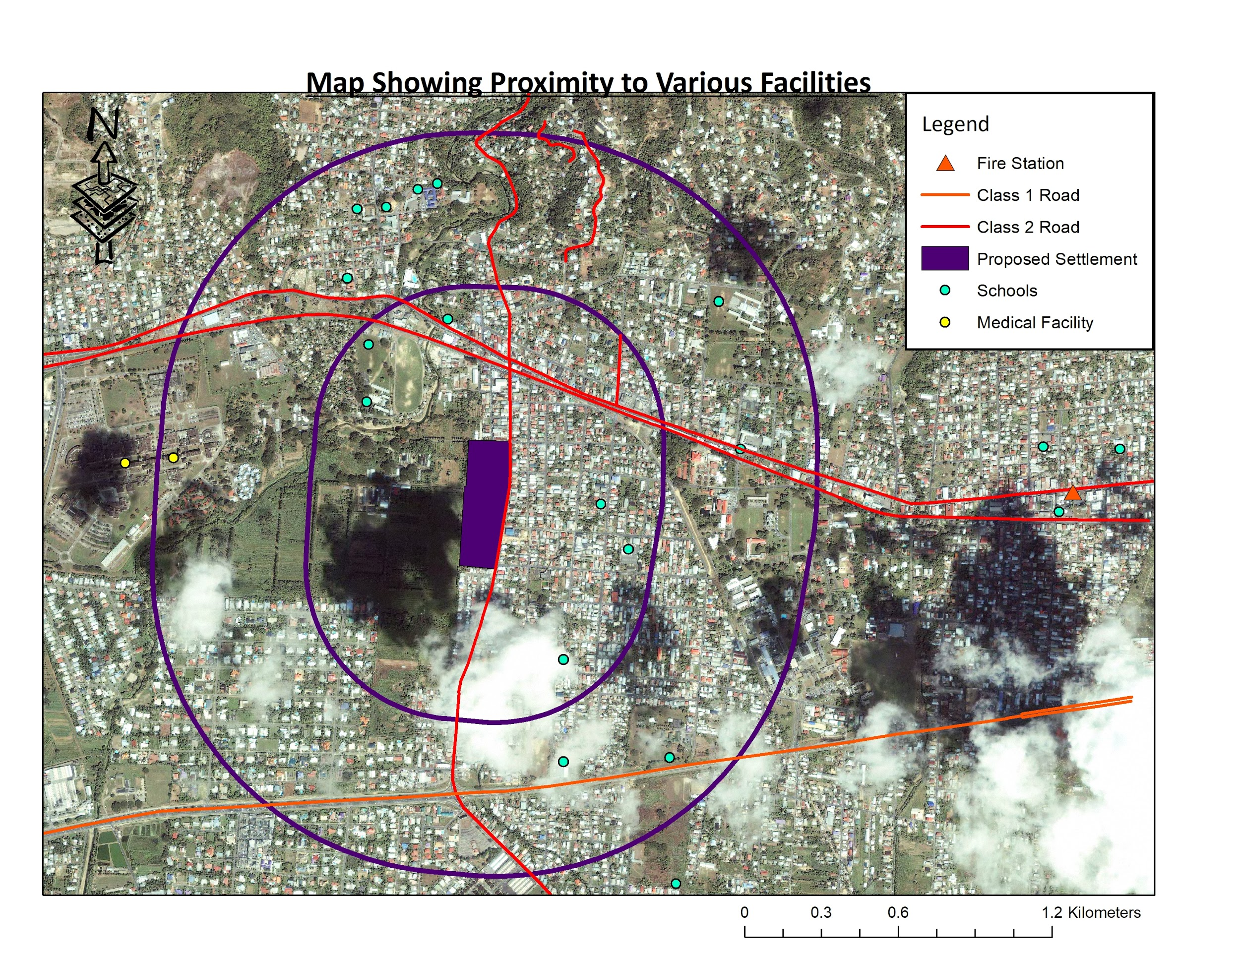

**Map 1: Showing All Pull Factors for Housing**

This map shows all the land based features that provide points for promoting the expansion of the HDC housing onto the Nursery lands. These include 6 schools that exist in a 600m radius of the proposed housing district, 9 schools as well as a medical facility that exist within a 1200m radius, its close proximity to class 1 and 2 roads, the nearest fire station being approx. 2200m away but is connected directly by a major roadway which will significantly reduce response time.

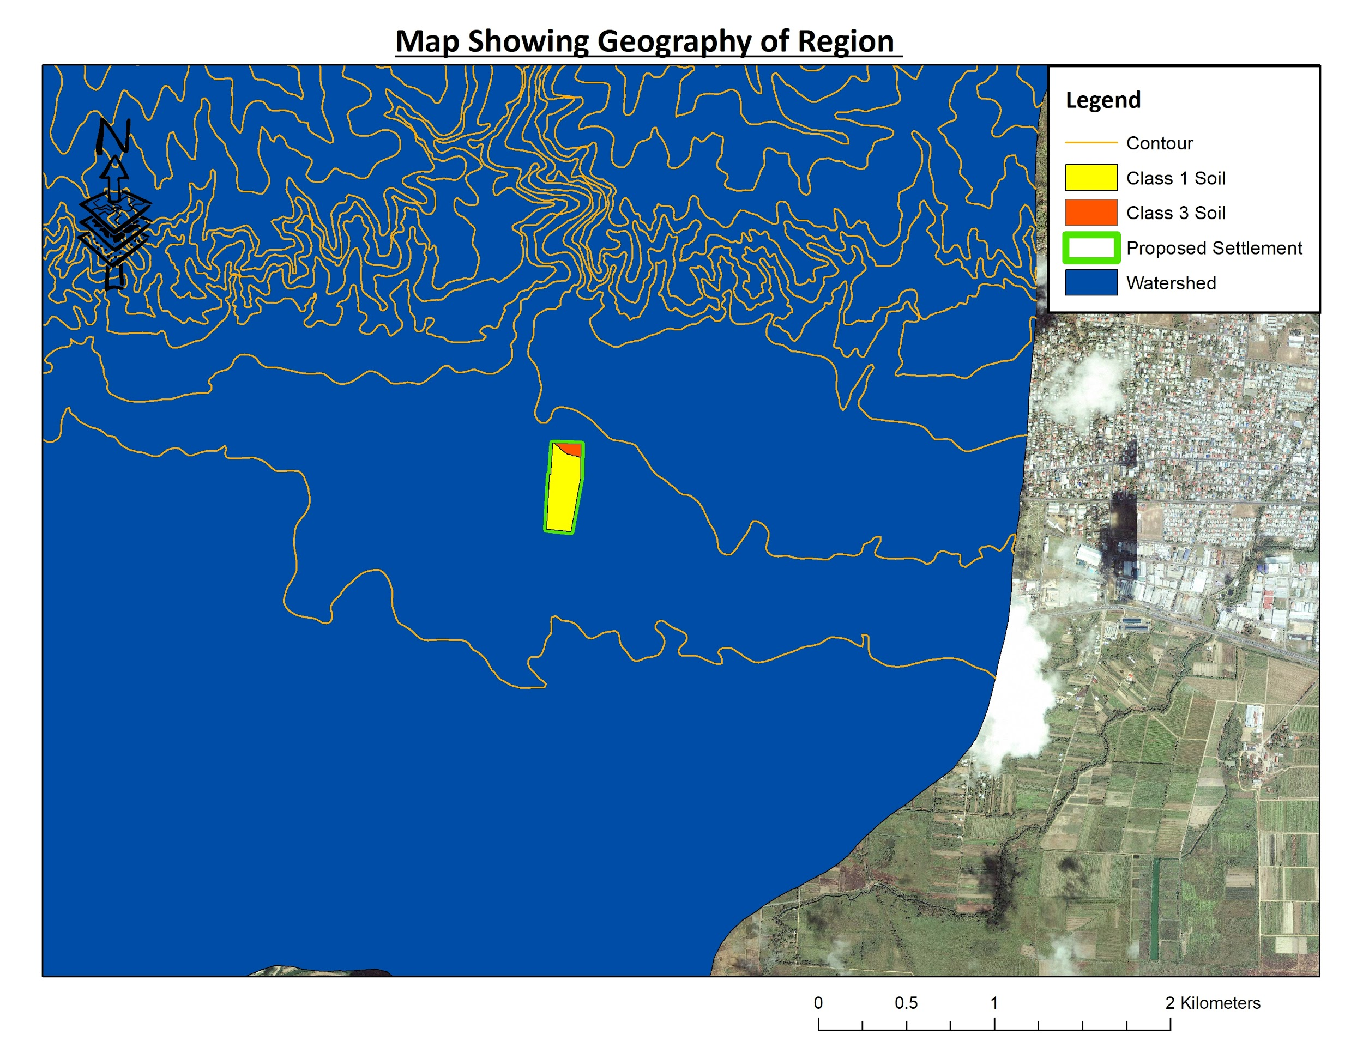

**Map 2: Showing Push Factors**

This map shows all the land based features that provide points as to why the Nursery should be kept. The majority of the proposed housing district exists on Class 1 soils whereas only a small section is class 3, indicating that the soil is valuable in terms of agriculture capabilities. Also, the site exists within a watershed, meaning the region would be flood prone. Additionally, the settlement would be built on relatively flat land, with a gentle slope.

**Main points noted during interview with Nursery officials:**

1. Main purpose of the nursery is propagation and production, not commercial.
2. Focuses on avocados, mangoes and until recently citrus. There are a variety of other exotic fruits at the nursery.
3. The nursery is not responsible for research and development
4. The nursery spanned 350 acres of land originally and over time there were 2 HDC housing phases were built reducing the size of the nursery to 80 acres, and the current issue will be phase 3 which plans to take 17 acres.
5. The nursery is 80% self-sufficient and the supply is more effective with less land as there a more concentrated workforce.
6. The nursery sells plants at a subsidy to farmers.
7. Plan B, the screen houses, would be as effective as plan A and the sick tress will be more manageable.
8. Modern technology and practices along the nursery would work more effectively with less land.
9. The nursery has existed since 1930 and may hold sentimental value.
10. Plants are not affected negatively by dense urban congestion (i.e. pollution).
11. Water is sourced from a WASA pipeline due to safety reasons.
12. There are no issues of flooding with increasing density, however praedial larceny is a problem.
13. Nursery officers are willing to compromise with government demands.
14. Class 1 soils can be replicated.
15. Workers are not an issue and no one will be laid off.
16. No hydroponics at the station or any plans to implement it as it does not involve propagation.
17. Fallen fruits are given to the wildlife division to be used as food.

**DISCUSSION**

The matter at hand is to determine whether a parcel of land at North Grove Curepe should be converted from its current agricultural purpose to residential. To determine the most suitable option a complete analysis of both the pull and push factors of using the land for urban (housing) use will be done.

Firstly the pull factors for constructing more HDC houses will be discussed. The pull factors of building the HDC houses at this location will be the provision of low cost housing in a densely populated area, topography and gradient of land is suitable for housing and there is availability of pre-existing infrastructure in the area.

Curepe is located along the east-west corridor. The east-west corridor is an expanse of land in the Northern region of the island that stretches from the capital, Port-of-Spain, to the far East town of Arima. It is a densely populated area characterized by the presence of a large number of amenities, such as; banking, schools, groceries, hospitals and three major transportation routes; the Priority Bus Route, the Eastern Main Road and the Churchill Roosevelt Highway. These transportation routes facilitate easy passage to and from towns within the area and access into Port-of-Spain. Due to these reasons many persons seek to reside within this region of the island. However, supply of housing does not meet the demand and in many cases where housing is available it is very costly. It is with this in mind that the government seeks out land in this region to build low income level houses so persons of middle class status can afford housing within the area. In prior years, the government has repurposed lands once dedicated to the nurseries to build HDC housing. They seek to continue the housing development because of the high demand. This view is replicated by both Ramsey and Corty (1982) and Krannich (2006) which states that due to high demand for housing agricultural lands are being repurposed. This region of the island is also experiencing economic growth due to numerous business development occurring. For example the neighboring town of Tunapuna has two miniature shopping malls in construction. Bhartendu and Seto (2015) stated that areas with economic growth experience more agricultural land loss.

Another pull factor of constructing HDC houses in the area is the slope and topography of the land is well suited for construction. Slope of land refers to the angle at which it deviates from zero, zero being completely flat land. A negative angle means a downward slope of the land like a valley and a positive slope value means an upward slope like a hill. The land at the nursery from observation done at the site visit, seemed flat with little deviation/change. Topography refers to physical features on the land’s surface. From observation there were no special or defined topographical features observed on the expanse of land.

The existence of proper infrastructure in the Curepe area is a major advantage as to why the houses should be constructed in the area. According to Map 1 there are 6 schools within a 600 m radius of the proposed housing site, a medical facility within a 1200m radius as well as 3 more schools and close proximity to class 1 and class 2 roads as well as a fire station approximately 2200m away. The fire station is connected directly by a major roadway which will significantly reduce response time. There is also a WASA pipeline located next to the proposed housing site which can provide water supply. There are telephone poles, electricity lines and cable services available. There are also the existence of fast food restaurants, banks, groceries and stores which increase the livability of the area. This point is supported by Krannich (2006) who explains that the rate at which agricultural land in areas adjacent to urban centers is developed will continue to increase as a function of the market.

Beside these pull factors, there are other circumstances which justify the construction of the HDC houses in this location; the Nursery is not being used to its full potential, the citrus trees are diseased and thus their production yield and quality of fruit are steadily decreasing, there is a backup plan already under way and lastly land is being offered at orange grove road. Currently the nursery has an area of 80 acres. The trees predominantly grown are citrus, avocado and breadfruit. The fruits of these trees are not sold but instead left on the tree to rot and fallen fruits are used to feed the wildlife division. It will be more efficient if fruit / produce were collected and sold to the public or market vendors, thus bringing in an increased means of income to the nursery besides the selling of seedlings and germplasm. Citrus trees are planted in abundance at the nursery. However they contain a disease called citrus greening. This disease affects the production yield and the quality of the fruit. The disease is incurable and causes the trees to produce less fruits as the disease progresses as well as fruit of lower quality.

Whilst at the station, the Foremen and the Manger mentioned that there was a plan B scenario already underway in the event that the nursery’s land is to be reclaimed for housing. This plan B involves the construction of screened houses. The manager and the foremen strongly expressed that this will be a better way of controlling the spread of the citrus greening disease as well as a more efficient means of managing plant seedling and germplasm production as the environment of the screened houses is more controlled and protected and also since the workforce will be more concentrated.

Furthermore, the pull factors for keeping the nurseries on the land in question will be discussed under five main headings. These include the environmental benefits, food security, sentimental value as well as downfalls of having the housing settlement built such as security issues and reduced aesthetic value.

Firstly, an environmental perspective is used when assessing whether the North Grove nursery should be converted to an urban area or left as agricultural land. Under this school of thought, the points to be considered are the size of the land, soil type, crops being produced and the conservation of certain species. The size of the nursery currently occupies 80 acres of land as revealed by officials at the nursery. However, when compared to the amount of land the nursery took up 51 years ago which spanned a vast 350 acres according to North Grove nursery officials, as well as to the amount of land the North Grove development which includes HDC housing for residential use, office buildings and agricultural lands; the nurseries actually occupy a fairly small land cover. The continued reduction of the nurseries can lead to issues in food security as will be discussed further.

According to officials at the site, as well as the maps used in this study, the soil type of the area proposed for conversion falls primarily under the Class 1 soils, with a small section falling under Class 3 soils. Based on the USDA Soil Taxonomy, Class 1 soils are described as being good lands, having few limitations that restrict their use with the ability to be easily cultivated. They describe Class 3 soils as being good land that requires moderate to intensive conservation and management practices. In short, they are the best lands for agricultural use thus making it vital to continue the agricultural production on these lands, since infrastructure can be adapted to be built on other areas not in use. When concrete structures are built on these soils, they are forever lost, unable to be used.

When advocating for the nurseries to stay, the presence of vital indigenous crops and their added value to the country culturally and socioeconomically should be considered. Some of the crops grown at the nursery include fruit plants that are indigenous to Trinidad. They are not always easy to get by, such as balata and caimate. As was noted on the day, these plants are grown in the same area as the diseased plants, thus these lands may be converted as well causing a great loss in these crops. Many of these crops may be hard to grow elsewhere if the environmental conditions are not right, and not all farmers would be willing to put out extensive work for them as not all lands are suited for agricultural use.

Additionally, some may think that the nearby plants can become infected, this is a misconception as the infected plants are being treated and regulated. The host plant was located and removed from the system and the disease causing animal was removed along with it thus making future infections highly unlikely. As it is, the trees present are still producing and are of no threat therefore, there is no need to remove these plants.

We can see from the article by Shahab Fazal (2000) entitled “Urban expansion and loss of agricultural land – a GIS based study of Saharanpur City, India,” how serious the issue may become if this trend continues, compromising ecological integrity and damaging vital natural space leading to other related environmental issues. Continued building on these fertile soils can lead to loss of prime agricultural soils as well as the contamination of the St. Joseph river, similar to this case of Saharanpur City in India.

Secondly, if the nurseries become compromised by having some of the land continuously stripped away, the present food security issue we face can become exacerbated. The presence of the nurseries provides vast socio-economic value to the general public as well as farmers. This includes the benefits of the germplasms. According to the University of California (2018), a germplasm is “living tissue from which new plants can be grown”. They utilize the seeds of healthy plants that are grown specifically for this purpose, or even certain parts of the plant such as leaves or stems and use these to create an entirely new plant with the same genetic makeup. In this way there is the continuation of certain species that are indigenous. Here, the germplasms provide benefits to the farmers by providing them with a supply of new plants without compromising the existence and diversity of the plants present at the nurseries. They also contribute to food security by providing food and fruit crops such as avocados, citrus and other small fruit crops. If the area in question were to be removed, it would lead to a reduction in supply to farmers. If the current trend of land being cleared for housing every few years continues as is, it would pose a threat to the future food security of the island as the nursery would reach a point where it can no longer effectively do its job. Not only would the agricultural sector be compromised, the current economic downturn in Trinidad would be exacerbated as the import bill would grow, reaching outrageously high numbers.

The article “Protection of agricultural land: An Institutionalist Approach” by J. C. Hite and B. L. Dillman (1981) backs this up stating that agricultural lands should be protected as they serve the function of providing a food supply, in the case of North Grove it does this through providing farmers with crops through germplasms. According to the article, it would also be one of the factors contributing to the flourishing of the agricultural sector and if these lands are continuously removed now and in the future, can cause the downfall of this ever important sector.

Thirdly, having been there for over 80 years, the nurseries would have gained a certain level of sentimental value to the locals. Persons living within Curepe as well as in neighboring areas would be accustomed to the nurseries as they are presently and would enjoy visits and tours around the compound. Older persons would reminisce when the area was larger and young children would marvel at the present span of the nurseries as well as the functions they serve and processes that take place. Budding agricultural students and farmers would benefit from the knowledge gained at the nursery as well as from the supply offered. The conversion of these lands into HDC housing would result in a decline in public interest and local support as the locals may feel as though the North Grove Nursery officials are giving up on the nurseries especially as time passes primarily for a payoff.

This is backed up by a study done by Andrew J. Huddy (2016) entitled “Farming Alone: Factors Influencing Farmland Conversion Along the Rural Urban Fringe”, they also stated that when doing their study and carrying out surveys, it was found that “there was an important association of strong, local, attachment value and the well-studied elements of land value and land use”.

The fourth point states that with the development of more housing in the area in close quarters to the nurseries, leaving it closed in; there would be greater security risks involved. The incidence of praedial larceny already exists; however with more infrastructures being built around the facility, the level would drastically. This can cause great losses to the nursery production and processes, the resource farmers rely on and the agricultural sector by extension. This could even lead to the eventual shut down of the nursery in extreme cases thus exacerbating the food security issue we already face. As a result of this, there would be the loss of capital as more money would need to be expended on security measures.

Finally, having the housing built near the nurseries would be an eyesore. The natural scene observed and enjoyed, the ambience experienced would be reduced by the development of housing in this area; especially being so close to the nursery. The area may appear to be “boxed in” by the development occurring on their outskirts.

**CONCLUSION**

This research was aimed at identifying which option was more beneficial, whether building on agricultural land for the purpose of housing for a growing population or the preservation of prime agricultural land which contains a variety of plant types. It was found that it would be more beneficial to preserve the St. Augustine Nurseries rather than for it to be utilized for housing. This can be attributed to reasons such as environmental benefits, food security and a sentimental value to the community while negative effects of the expansion of the HDC housing included increased praedial larceny as well as becoming an eyesore. This research assignment was very significant as it examined both the negative and positive sides of building on the nurseries for the purpose of housing and whether the nurseries should be preserved, which can be relevant to both educators as well as administrators interested in combating this geographical dilemma. This research assignment however utilizes past research which employs the use of both qualitative and quantitative data.

**REFERENCES**

1. Taylor, Nigel. 1998. *Urban Planning Theory Since 1945*. London: SAGE.
2. Ministry of Agriculture, Land and Fisheries. 2013. "Agricultural Services Division". Accessed April 06, 2018. [http://agriculture.gov.tt/divisions-and-units/divisions/agricultural-services-division.htm**l**](http://agriculture.gov.tt/divisions-and-units/divisions/agricultural-services-division.html)**.**
3. Fazal, Shahab. 2000. "Urban Expansion and Loss of Agricultural Land- a GIS Based Study of Saharanpur City India." *Environment and Urbanization* 12 (2) : 133-49. <https://doi.org/10.1177/095624780001200211>.
4. Ramsey, A. Frank, and Floyd L. Corty. 1982. "Conversion of Prime Agricultural Land to Non-Agricultural Uses in One Area of the Sunbelt." *Southern Journal of Agricultural Economics* 14 (2): 23-29. <https://ageconsearch.umn.edu/bitstream/30455/1/14020023.pdf>.
5. Hite, J. C., and B. L. Dillman. 1981. "Protection of Agricultural Land: An Institutionalist Perspective." *Southern Journal of Agricultural Economics* 13 (1): 43-53. <https://ageconsearch.umn.edu/record/30455/files/14020023.pdf?version=1>.
6. Krannich, Jess. 2006. “A Modern Disaster: Agricultural Land, Urban Growth and the Need for a Federally Organized Comprehensive Land Use Planning Model.” *Cornell Journal of Law and Public Policy* 6 (1) :57-99. <https://scholarship.law.cornell.edu/cgi/viewcontent.cgi?referer=https://www.google.tt/&httpsredir=1&article=1104&context=cjlpp>
7. Pandey, Bhartendu, and Karen C. Seto. 2015. “Urbanization and agricultural land loss in India: Comparing satellite estimates with census data.” *Journal of Environmental Management* 148 : 53-66. [https://doi.org/10.1016/j.jenvman.2014.05.014](https://doi-org.ezproxygateway.sastudents.uwi.tt/10.1016/j.jenvman.2014.05.014).
8. The Ministry of Housing and Urban Development (MHUD). 2018. “Ag Minister: New Curepe Housing Community will redound to the benefit of all stakeholders.” MHUD. Accessed April 20, 2018. <http://www.housing.gov.tt/ag-minister-new-curepe-housing-community-will-redound-benefit-stakeholders/>.
9. Huddy, Andrew J. 2016. “Farming Alone: Factors Influencing Farmland Conversion Along the Rural Urban Fringe.” Doctoral Dissertations. <https://opencommons.uconn.edu/cgi/viewcontent.cgi?referer=https://www.google.tt/&httpsredir=1&article=7470&context=dissertations>.
10. Business Dictionary. 2018. “planned urban development (PUD).” (BD). Accessed April 21, 2018. <http://www.businessdictionary.com/definition/planned-urban-development-PUD.html>.
11. Susan S. Fainstein. 2018. “Urban planning.” Encyclopedia Britannica. Accessed April 21, 2018. <https://www.britannica.com/topic/urban-planning>.
12. Seed Biotechnology Centre. 2018. “Germplasm.” University of California. Accessed April 21, 2018. <http://sbc.ucdavis.edu/About_US/Seed_Biotechnologies/Germplasm/>.